KLIMATSKA OBILJEŽJA REPUBLIKE HRVATSKE

**1. Objasni svojim riječima.**

1. Navedi klimatske modifikatore (čimbenike) koji utječu na klimu Republike Hrvatske?

___________________________________________________________________________________

___________________________________________________________________________________

___________________________________________________________________________________.

1. Što je kontinentalnost?______________________________________________________________

___________________________________________________________________________________.

**2. Sljedeći zadatak riješi pomoću priložene karte *Srednje temperature zraka u Republici Hrvatskoj u***

***srpnju.***

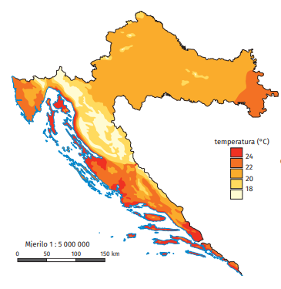

1. Promotri kartu i navedi tri područja u Republici Hrvatskoj koja imaju najviše srednje temperature zraka ljeti.______________________________________________________________________

______________________________________________________________________________.

1. Navedi dvije županije koje imaju najniže srednje temperature zraka ljeti._____________________

_______________________________________________________________________________.

**3. Sljedeći zadatak riješi pomoću priložene karte *Prosječne godišnje količine padalina u Republici***

***Hrvatskoj.***

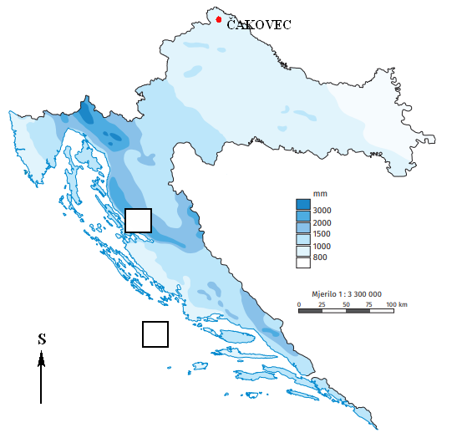

1. Promotri kartu i navedi regiju Republike Hrvatske koja prima najvišu količinu padalina.

___________________________________________________________________________.

1. Objasni zbog čega količina padalina opada prema istoku.______________________________

___________________________________________________________________________

___________________________________________________________________________.

1. Uz pomoć tumača karte odredi kolika je prosječna količina padalina u Čakovcu.

___________________________________________________________________________.

1. U prazne kvadratiće ucrtaj strelicu smjera puhanja bure i juga.