The world in the palm of your hand

Danijela Perenc-Jaušovec

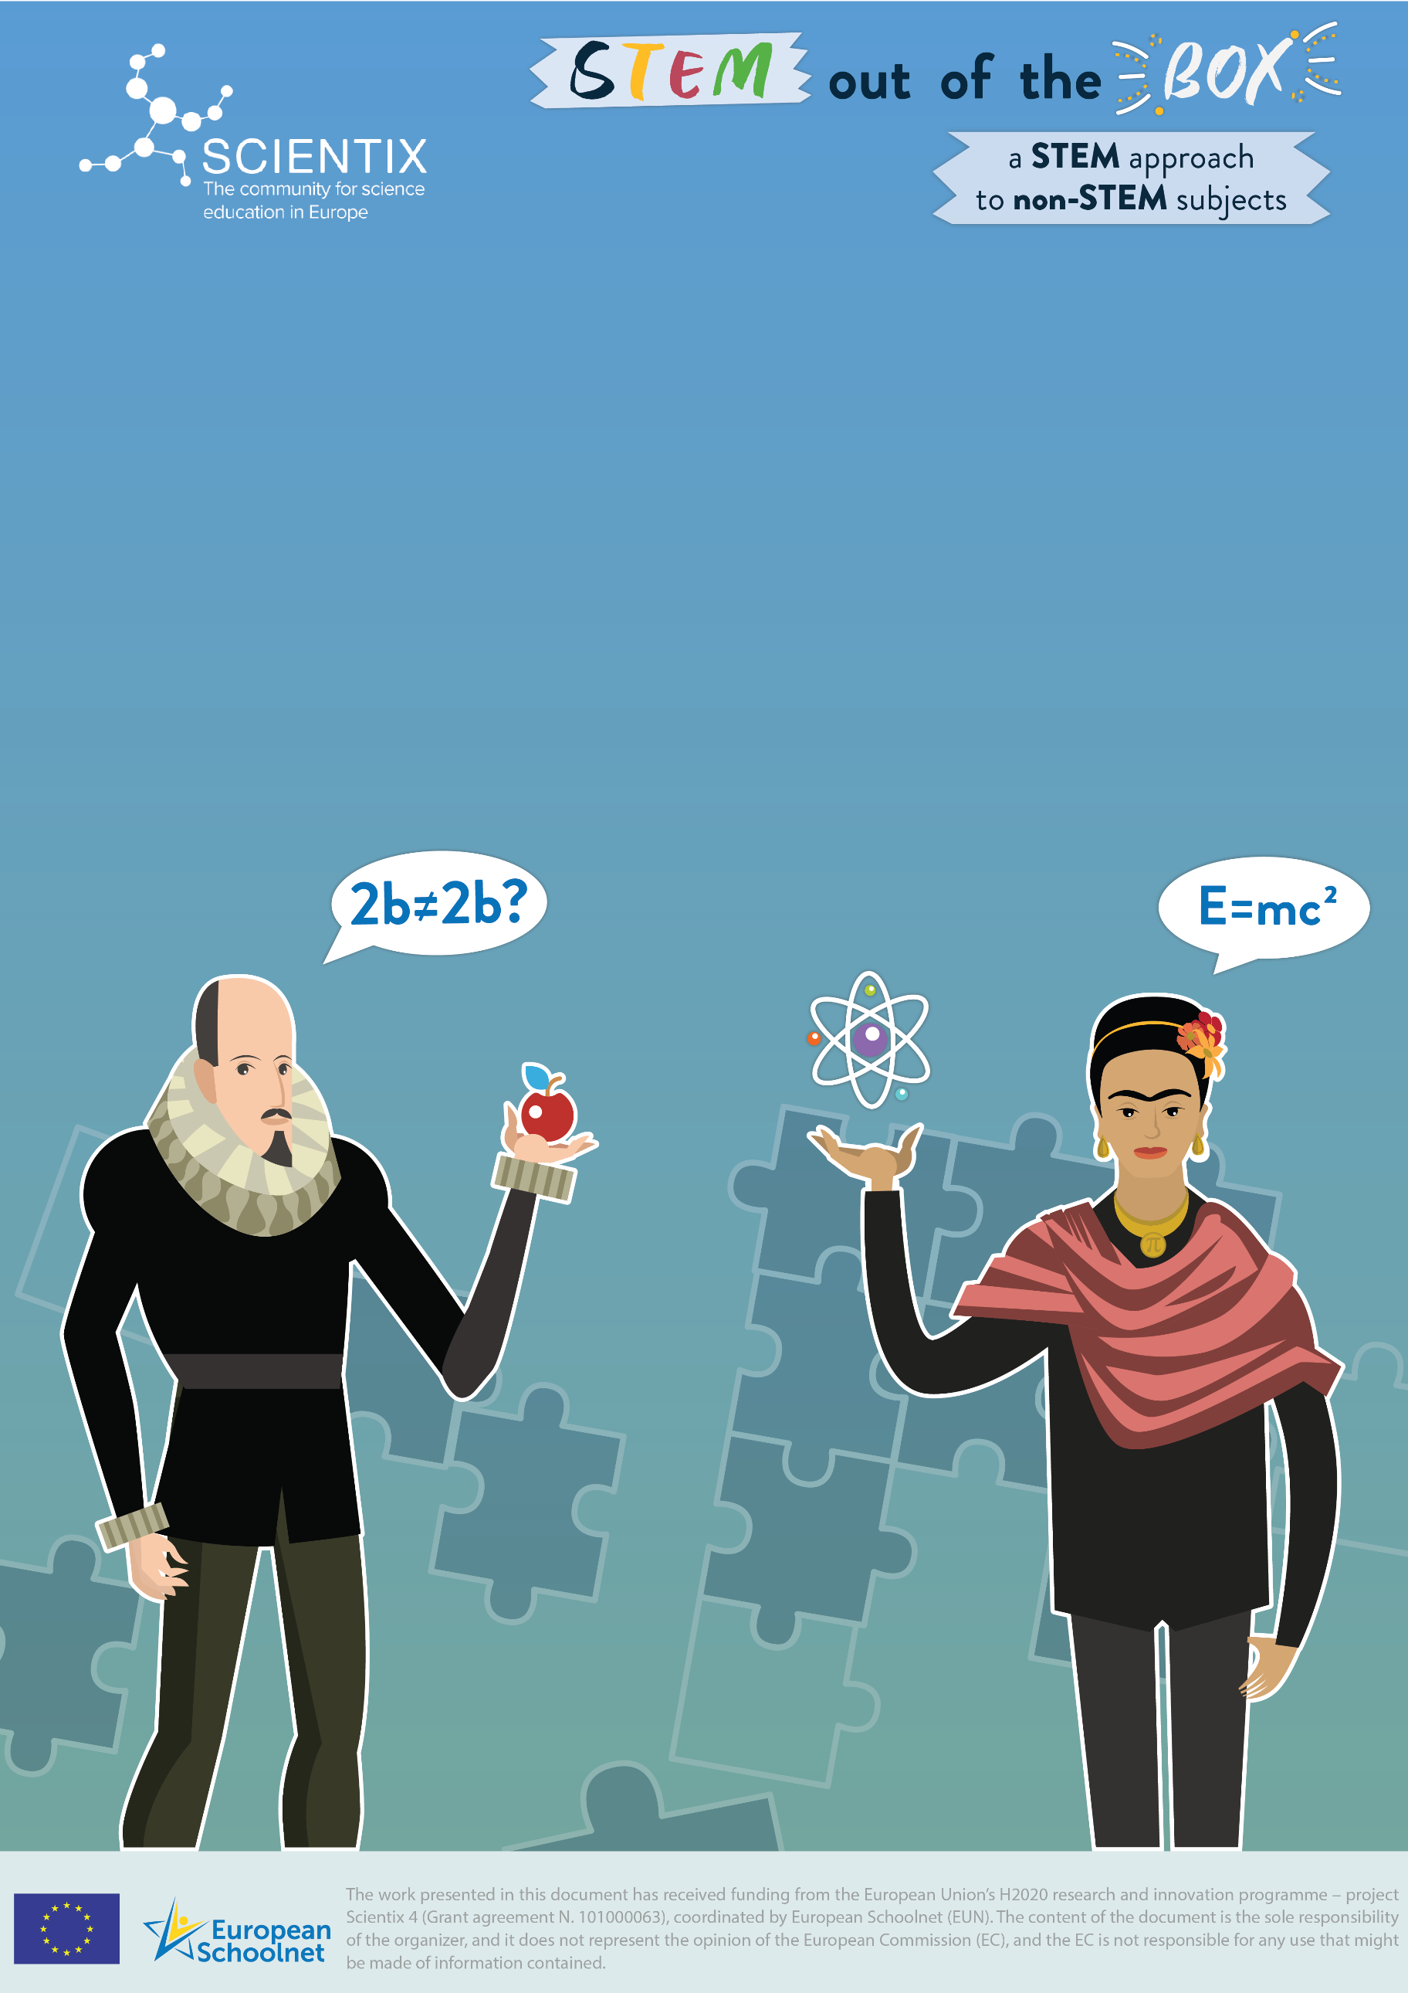

Scientix Learning ScEnario

# Title

The world in the palm of your hand

# Author(s)

Renata Najman, Danijela Perenc - Jaušovec

# Summary

The purpose of this scenario is developing students' competencies for research work, to connect the content of geography with the content of chemistry, to develop entrepreneurial skills with the use of various digital tools and to encourage students to cooperate with each other and with their community.

# Keywords

Climates, plants, soap, teamwork, entrepreneurship

# License

**Attribution ShareAlike CC BY-SA.** This license lets others remix, tweak, and build upon your work even for commercial purposes, as long as they credit the original creation and license their new creations under the identical terms.

# Overview

|  |  |
| --- | --- |
| *Subject(s)* | List all the subjects that this learning scenario is intended for. If this is an interdisciplinary lesson, list multiple subjects.  Geography  Chemistry  Mathematics  Native language  Art |
| *Topic(s)* | The world in the palm of your hand |
| *Age of students* | 14-15 years old |
| *Preparation time* | 6 hours |
| *Teaching time* | 10 hours |
| *Online teaching material* | Internet browser, Canva, Microsofts Teams, Padlet, |
| *Offline teaching material* | World Map, Computer, Printer, paper, scissors, glue, ruler, decorative ribbons, chemicals (sodium hydroxide, olive oil, coconut oil, water, essential oils of various fragrances, pigments), plastic containers, scales, electric hobs, cookers, measuring cups etc. |
| *Resources used* | List here links of ALL the resources used for this learning scenario (links to *YouTube* videos, article pdf’s, links to online articles, etc.).  What is biome? <https://www.meteorologiaenred.com/hr/biomas.html>  Climate classes on Earth: <https://youtu.be/ij3sv7-IJ2I>  Climatic factors: <https://youtu.be/F75as52oN9Q>  Consequences of climate change on flora and fauna: <https://klimatskepromjene.hr/katastrofalne-posljedice-klimatskih-promjena-na-biljni-i-zivotinjski-svijet/>  European Red List of Medicinal Plants: <https://ec.europa.eu/environment/nature/conservation/species/redlist/downloads/European_med_plants.pdf>  Medicinal Plants of North America: <https://vetmed.tamu.edu/peer/wp-content/uploads/sites/72/2020/04/DLC808_Medicinal-Plants-of-North-America.pdf>  Africa Plants: <https://theconversation.com/africa-is-a-treasure-trove-of-medicinal-plants-here-are-seven-that-are-popular-184189>  Plants of Asia: <https://blog.biodiversitylibrary.org/2021/07/plant-trade-and-medicinal-plants-in-asia.html>  Green gold from Amazonia: <https://www.oroverde.cz/?lang=en>  How to make soap: <https://prirodna.hr/postupak-izrade-sapuna> |

# Aim of the lesson

Train students to use geographic literacy, logical thinking, language, communication and social skills to think critically about spatial problems and contribute to finding creative and innovative solutions in everyday life and lifelong learning.

Develop entrepreneurship competence, one of the key competences of the European reference framework for lifelong learning, which is necessary for every citizen to be able to be (self) employed and to develop personally in the knowledge society.

Building a healthy, self-confident, creative, productive, proactive, satisfied and responsible person capable of cooperation and contribution to the community.

# Trends

Peer Learning: students learn from peers and give each other feedback.

STEM Learning: Increased focus on Science, Technology, Engineering, Mathematics subjects in the curriculum

Lifelong Learning: learning does not stop when leaving school.

Project-Based Learning: students get fact-based tasks, problems to solve and they work in groups. This kind of learning usually transcends traditional subjects.

Assessment: the focus of assessments is shifting from "what you know" to "what you can do."

Visual Search & Learning: images and multimedia are more powerful than verbal stimuli.

# 21st century skills

**Creativity and Innovation**: will generate ideas and learn how to respond to a challenge.

**Critical Thinking and Problem Solving**: Students will explore ideas, discuss and consider other points of view.

**Communication:** Students will work on their reading, writing, speaking and listening skills to engage in productive discussions.

**Collaboration**: Students will complete activities while working in pairs and groups.

**Media Literacy:** The skill required to create a video reportage.

**ICT (Information, Communications, and Technology) Literacy:** Students will learn how to look for and filter information.

**Leadership and Responsibility:** Students will develop the ability to guide and motivate each other.

# STEM Strategy Criteria

Connections with industry: in the context of this Learning Scenario, the students visited the procurement department of a company in order to learn about the factors that influence the calculation of the price of the final product. They also visited their sales department in order to learn about different ways of advertising products.

Interdisciplinary instruction: in this Learning Scenario, we will examine and implement a variety of activities in a wide spectrum of subjects, ranging from geography, english and native language, art (non-STEM) to ICT, mathematics and chemistry (STEM).

| **Elements and criteria** | **How is this criterion addressed in the learning scenario** |
| --- | --- |
| **Instruction** |  |
| Personalization of learning | Collaborative work is facilitated: each student is invited to  assume a role in the team, according to his/her aptitudes  and skills. |
| Problem and project-based learning (PBL) | Students should investigate how the climate of the continents affects the development of plants. Can we represent individual continents with specific plants? How to make soap? |
| Inquiry-Based Science Education (IBSE) | Students have the opportunity to explore the biodiversity of the world. |
| **Curriculum implementation** |  |
| Emphasis on STEM topics and competencies | Scientific communication will be practised through class  debate and presentations as groups or individuals. |
| Interdisciplinary instruction | The tasks implemented cover various subjects, both  STEM (Chemistry, Mathematic, ICT) and non-STEM (Art,  English and Native Language). |
| Contextualization of STEM teaching | The students experience the applications of  concepts in their everyday environment. |
| **Assessment** |  |
| Continuous assessment | A portfolio evaluation is carried out, allowing a  continuous check on the students’ progress. |
| Personalized assessment | In order to make learning more meaningful, this Learning  Scenario shifts from assessment-driven to learnerfocused lessons and incorporates the use of  technologies. By involving staff in the process of defining  what assessment means to them, a shared  understanding and vision for formative assessment in the  school can be developed to promote a whole-school  approach to personalised formative assessment. |
| **Professionalization of staff** |  |
| Highly qualified professionals | This LS is intended to be implemented by teachers  specialised in STEM education and in social sciences. |
| Existence of supporting (pedagogical) staff | In this LS, the school support staff play an important role  in ensuring a safe and supportive learning environment:  they provide specialised instructional support and help  students when they use the school facilities needed to  implement the planned lessons. |
| Professional development |  |
| **School leadership and culture** |  |
| School leadership | The students improve career competency skills by  working in groups and acquire transferable computer  skills that build data literacy. |
| High level of cooperation among staff | This LS is strongly cross-curricular: each lesson  embraces diverse perspectives on the topic, so the  teachers should cooperate to address it in the classroom. |
| Inclusive culture | This LS attempts to adopt inclusive teaching by moving  the learning setting to a computer lab rather than  requiring the students to have personal computers with  the necessary programs already installed. Free and userfriendly apps are also used for performing tasks. |
| **Connections** |  |
| With industry | In the context of this Learning Scenario, the students visited the procurement department of a company in order to learn about the factors that influence the calculation of the price of the final product. They also visited their sales department in order to learn about different ways of advertising products. |
| With parents/guardians | The students’ age means parents are not involved as  safety guardians |
| With other schools and/or educational platforms |  |
| With universities and/or research centers |  |
| With local communities | The students contribute to a community/citizen science  research project. |
| **School infrastructure** |  |
| Access to technology and equipment | Schools should be equipped with Internet access, as well  as at least one computer/laptop and one projector per  group of students.  Digital cameras can be loaned to the students. |
| High quality instruction classroom materials | Access to a mobile device (such as a smartphone or  tablet with an Internet connection) that can take a  photograph outside is a central requirement of this LS. |

# Lesson Plan

|  |  |  |
| --- | --- | --- |
| Name of activity | Procedure | Duration |
| Ice breaker  activity  (Personal and social development) | The teacher asks the question *What is a biome*?  Students try to answer the question.  What factors affect biomes? What types of biomes exist on Earth?  After one of the students connects the given term with biology, the teacher gives a guideline, a link where the answer can be found. <https://www.meteorologiaenred.com/hr/biomas.html>  On which continents do some types of biomes occur?  Students will be divided into seven groups. Each one has its own task - to study the biome of a particular continent. | 10 min |
| Collecting  evidence  (Geography) | Working in groups, students collect information about the biome of the given continent and record it on Padlet. <https://padlet.com/renatan2015/qju67g52az2ore9h>  They collect data by watching videos on <https://youtu.be/ij3sv7-IJ2I>  i <https://youtu.be/F75as52oN9Q>  They also collect data on links: <https://www.meteorologiaenred.com/hr/biomas.html>  <https://klimatskepromjene.hr/katastrofalne-posljedice-klimatskih-promjena-na-biljni-i-zivotinjski-svijet/> | 70 min |
| Discussion  (Geography) | Each group presents the data they have collected to the other students in the class, then they analyze and discuss the data collected (notice similarities and differences). They connect data with geographic location and climate. The teacher moderates the discussion and asks questions that lead students to the impact of climate on biodiversity. | 30 min |
| Reading and understanding the articles  (English as a  second  language) | European Red List of Medicinal Plants: <https://ec.europa.eu/environment/nature/conservation/species/redlist/downloads/European_med_plants.pdf>  Medicinal Plants of North America <https://vetmed.tamu.edu/peer/wp-content/uploads/sites/72/2020/04/DLC808_Medicinal-Plants-of-North-America.pdf>  Plants of Africa: <https://theconversation.com/africa-is-a-treasure-trove-of-medicinal-plants-here-are-seven-that-are-popular-184189>  Plants of Asia: <https://blog.biodiversitylibrary.org/2021/07/plant-trade-and-medicinal-plants-in-asia.html>  Green gold from Amazonia: <https://www.oroverde.cz/?lang=en>  The students work by themselves. Each student takes notes. | 60 min |
| Discussion  (Science) | Students discuss the content, read and compare their notes. They discuss the possible application of plants. What could they use the plants and their essential oils for. | 15 min |
| PBL  (Chemistry) | How to make soap?  Information on soap making is available at <https://prirodna.hr/postupak-izrade-sapuna>  They create a list of chemicals needed to make soap. They agree on what to do with the resulting soaps. | 30 min |
| Case study  Activity  (Entrepreneurship) | Soaps, which will represent individual continents with characteristic plants, are intended to be sold at the school charity fair. Therefore, they must be well organized, divided into four groups, according to their own affinities.   1. Economic group - they research where they can get the required chemicals; they visit the procurement department of another company and learn how the final price of a product is determined. To complete the tasks, knowledge of mathematics is required. 2. Development - this group designs recipes that will be used to make soaps. They apply knowledge of chemistry. 3. Packaging - the group comes up with the name of the soap collection and designs the packaging using knowledge of geometry, art and native language 4. Promotion and sales - designs posters or video reportage to advertise soaps using art and ICT skills | 5h |
| Conclusion  (Personal and social development) | Through their work, the students demonstrated creativity, innovation, the ability to reasonably take risks, as well as the ability to plan, organize and lead projects in order to achieve certain goals.  They also showed that they can respect each other's differences, developed solidarity and responsible behavior. | 5 min |
| Sale at the school charity fair  (Citizenship  and  development) | Students in groups sell soaps at the school fair to raise funds to help students treat illnesses, to help finance excursions, etc. | 90 min |

# Assessment

This Learning Scenario offers several opportunities for formative assessment. The students participated with great enthusiasm in all the activities. They showed sincere interest in the final task - making soap. You can see photos of soap making in the last item.

# Student feedback

We got the students' feedback by talking to them; they were very satisfied with the result of their work and the amount of money we collected at the fair. They expressed their desire to continue working, to expand the range of products, and to try to make soap molds ourselves using 3D printing technology.

# Teachers’ remarks

Positive atmosphere throughout the work, active involvement of those students who are not active in traditional classes.

# About Scientix

Scientix, the community for Science Education in Europe, promotes and supports a Europe-wide collaboration among STEM (Science, Technology, Engineering and Mathematics) teachers, education researchers, policymakers and other STEM education professionals. If you need more information, check the [Scientix portal](http://www.scientix.eu/home), or contact either the Scientix National Contact Point or Scientix Ambassadors [in your country](http://www.scientix.eu/in-your-country).

# Annex(es)

Add here any annex(es) for the Learning Scenario, if needed.

